

Machine Learning component for the motor control software of an electrical car
The latest generation of automotive micro-controller units (MCU) contain hardware blocks to run machine learning (ML) algorithms. At Tremec we intend to use such MCU’s in our inverters, which together with the electric motor form the most important part of the electric drive unit (EDU) in electric vehicles (EV).

In high performance EV applications, the traction inverter is the core element that allows a particular motor to shine and deliver its maximum performance. High speed Space Vector PWM (SVPWM), Field Oriented Control (FOC) together with an angle tracking observer (ATO) are the main methods of the motor control software to realize this. But methods to reduce the noise of the in- and output signals are maybe even more important.

With this thesis, we want to learn where ML can be useful for motor control software and gain practical knowledge on how to implement such models in an automotive MCU..

Keywords: Automotive, Electrification, Electrical Vehicle (EV), Traction Inverter, AI, ML, ANN, embedded, MCU
Goal – The goal is twofold, the first one high-level and the second one embedded:
- Many papers refer on using Machine Learning (ML) techniques to replace some parts of the inverter software. Select or create such a model:
- back-EMF rotor position estimation
- SVPWM
- RDC, ATO
- Speed control loop
- Motor temperature model
- ...
- The new Infineon MCU (TC4xx) contains DSPs that can be used for ML: implement a TensorFlow model on it.
Approach – A literature study on the use of AI/ML techniques on inverter software should make clear what parts of the software could be replaced by ML, where are the gaps, what are the gains or risks, and what part will be used for this thesis. Then the model must be created, simulated, … , and finally be tested on our test bench. Figure 1 shows an AI development cycle proposed by Infineon.
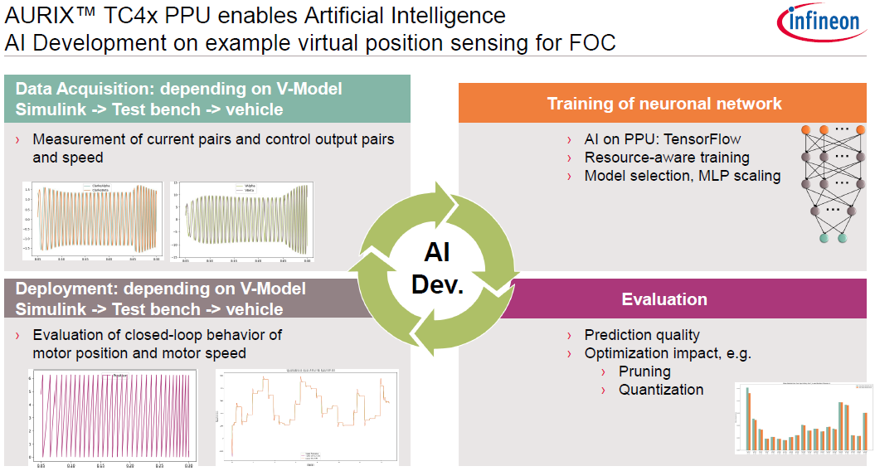
Figure 1. Infineon Technologies AG marketing slide for their new MCU

At Tremec, we use a model-based development workflow based on Matlab/Simulink, and that workflow will have to be extended to include ML tools.
Then using the Tasking compiler, the ML model must be programmed into the Parallel Processing Unit (PPU), a unit containing multiple DSPs. Figure 2 shows both the software and the hardware part.
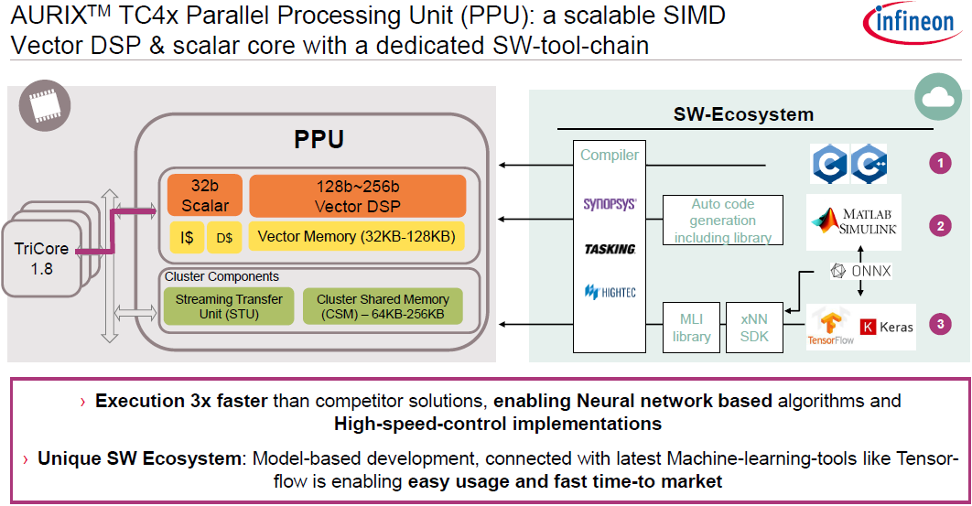
Figure 2. Infineon Technologies AG marketing slide for their new MCU
Finally, the new software will have to be verified on Tremec’s low-voltage EDU test bench.
Duration – 1 academic year (1 or 2 people)
Profile – Master's degree in electrical or computer science engineering, with a strong interest in embedded real-time software development, analytical modelling, simulation, and experimental validation. As the subject spans multiple physical domains of technology, a broad interest in several engineering disciplines (embedded software, electronics & mechanics) is desired.
Contacts
Jürgen Lambrecht – BSW engineer
De student kan zich aanmelden via jobs.be@tremec.com t.a.v. Yana Feyers


De Arend 14/1
B – 8210 Zedelgem
www.tremec.com

